**DC Supplement Adapter**

1-08618-00

*Thank you for purchasing an APH product.*

**Important: Before using the batteries the first time, charge them overnight.** Do not completely discharge them before recharging. Recharge them frequently. Your adapter comes with a spare set of batteries so you can recharge one set while using the other set.

**Using the DC Supplement Adapter with the APH Select Switch**

Connect the item to the APH Select Switch (a battery-powered, combination switch and environmental control unit, sold separately, APH catalog number 1-08617-00) using the APH DC Supplement Adapter (DCSA) (sold separately, APH catalog number 1-08618-00). Turn on the item and then turn on the Select Switch. Applicable with the following items:

* APH Sensory Learning Kit Fan (Honeywell w/o cord and USB adapter)
  + Uses DCSA **Polarity I** with Select Switch (face the knobs and slide switch to right).
* APH Sensory Learning Kit Fan (Caframo)
  + Uses DCSA **Polarity II** with Select Switch (face the knobs and slide switch to right), see page 3.
* APH Sensory Learning Kit Vibrating Pad
  + Uses either **Polarity I or II** with Select Switch (face the knobs and slide switch to right).

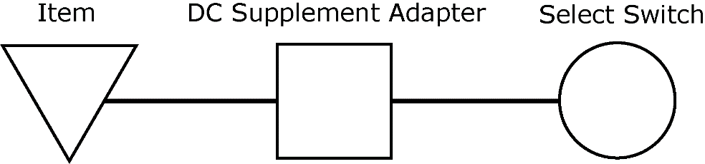

**Using the DC Supplement Adapter with a standard switch**

Plug any standard switch into the APH DC Supplement Adapter and then plug the DC Supplement Adapter into the item. Note that **APH does not recommend** this for daily or long-time use because it can quickly exhaust the battery life of the DC Supplement Adapter, which operates using two lithium-ion batteries (3.7 volts each). Note correct polarities explained earlier. Applicable with the following items:

* APH Sensory Learning Kit Fan (Honeywell w/o cord/adapter)
* APH Sensory Learning Kit Fan (Caframo) (See page 3.)
* APH Sensory Learning Kit Vibrating Pad

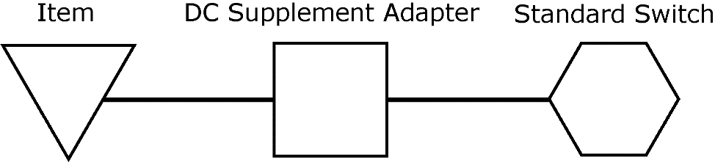

**Parts List: DC Supplement Adapter—1-08618-00**

**Item Description Quantity**

Adapter 1

Recharger 1

3.7V Lithium-ion batteries 4

Print Braille download note 1

APH does not sell replacement parts for the DC Supplement Adapter. These instructions are available on the APH shopping site or manuals download page.

Note: Before returning APH products to APH for service, replace old batteries with new or recharged ones and reverse polarity for both the Select Switch and the DC Supplement Adapter.

**Troubleshooting.** If the item operates immediately and does not turn off, reverse the polarity on the Select Switch (slide switch under the control knobs). If you cannot turn on the item, switch the power polarity using the in-line polarity switch on the DC Supplement Adapter cable to provide correct power polarity to the item.

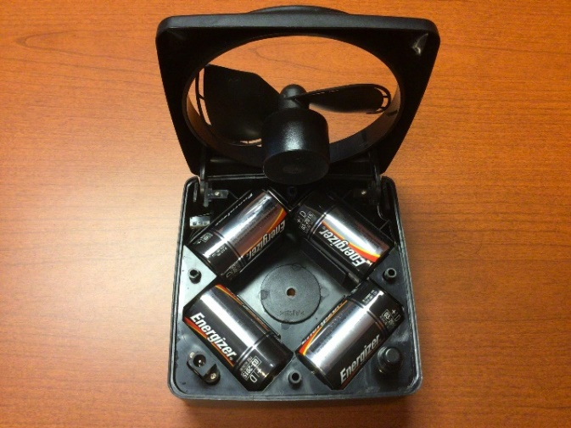**Option 1**: Caframo fan with diamond-shaped battery configuration, switch jack on left, and push button power supply on right DOES NOT WORK with the DC Supplement Adapter.

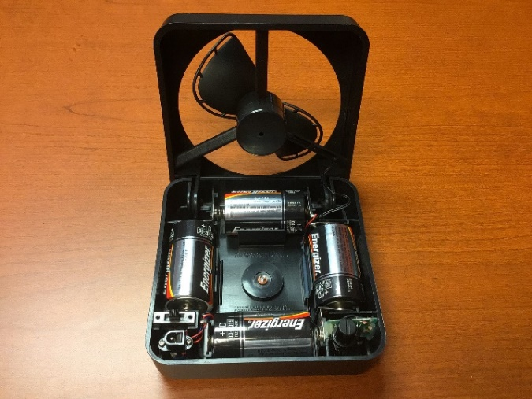**Option 2**: Caframo fan with square-shaped battery configuration, slide power switch and switch jack on the left, and speed control knob on the right, DOES WORK with the DC Supplement Adapter on Polarity II.

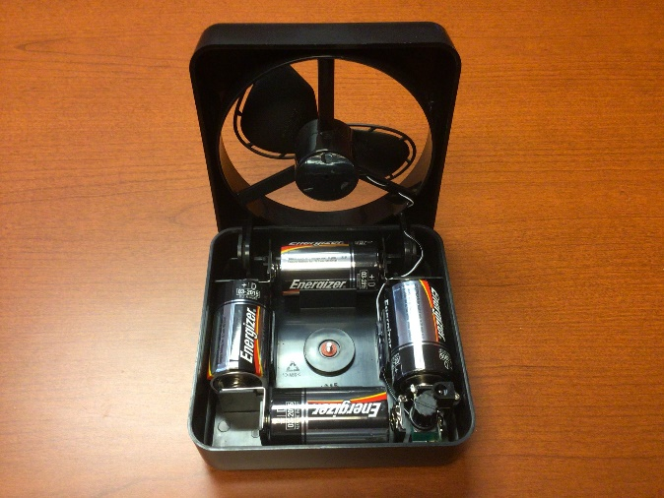

**Option 3**: Caframo fan with square-shaped battery configuration and combination power and speed control knob on the right, DOES WORK with the DC Supplement Adapter on Polarity II.



**1-800-223-1839 APH.ORG**